

**CSE 240 Data Science with R**

**STUDENT WORK BOOK**

|  |  |  |
| --- | --- | --- |
| **Name** | **:** | M.Sathishkumar |
| **Unique ID** | **:** | E0119052 |
| **Year** | **:** | II |
| **Quarter** | **:** | Q6 |
| **Department** | **:** | B.Tech CSE (AI &ML) |
| **Faculty Name** | **:** | Prof.B.Nirmala |
| **Academic Year** | **:** | 2020-2021 |

**Date:02/11/2020**

**Q.NO 1: Question**

Consider 2 vectors c(9,10,11,12) and c(13,14,15,16).

Create a 4 by 2 matrix from these two vectors

**Program:**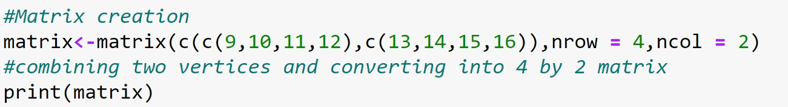

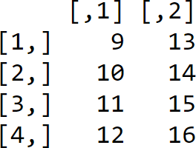 **Output:**

**Explanation:**

* Matrix is a two-dimensional data structure in R programming.
* Matrix can be created using the matrix () function
* Dimension of the matrix can be defined by passing appropriate value guments nrow and ncol

**Date: 02/11/2020**

**Q.NO 2: Question**

**Program:**

Write an R program to take input from the user (userID and Group/Branch) and display the values

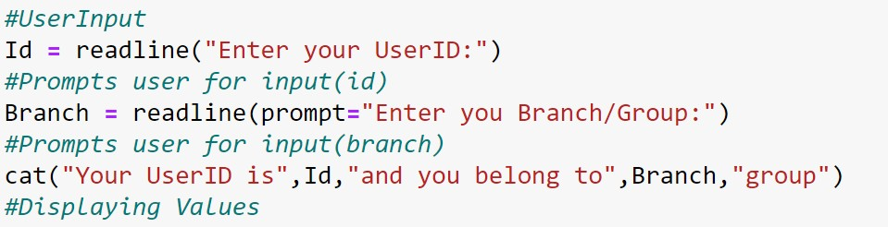

**Output:**

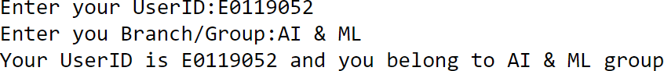

**Explanation:**

* readline reads a line from the terminal (in interactive use).
* readline() lets the user enter a one-line string at the terminal.
* The prompt argument is printed in front of the user input. It usually ends on ": ".

**Date: 02/11/2020**

**Q.NO 3: Question**

Create a data frame Write a R program to create a data frame from four given vectors.

a name b. Subject C. Score d. Rank

**Program:**

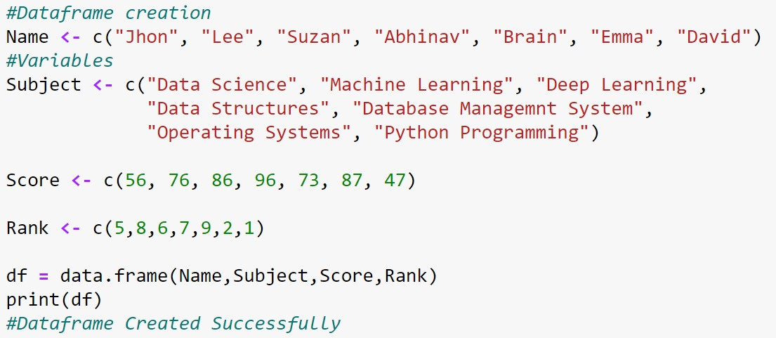

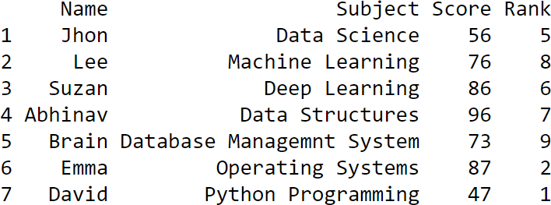**Output:**

**Explanation:**

* A **data frame** is used for storing data tables. It is a list of vectors of equal length.
* The top line of the table, called the **header**, contains the column names.
* Each horizontal line afterward denotes a **data row**, which begins with header, and then followed by the actual data.
* Each data member of a row is called a **cell**.

**Date: 02/11/2020**

**Q.NO 4: Question**

Write a R program to get the statistical summary and nature of the data of a given data frame. ( use 3rd Question dataframe

**Program:**

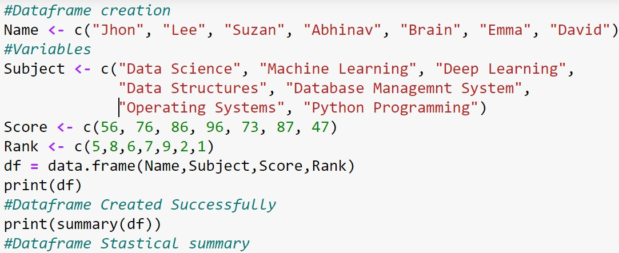

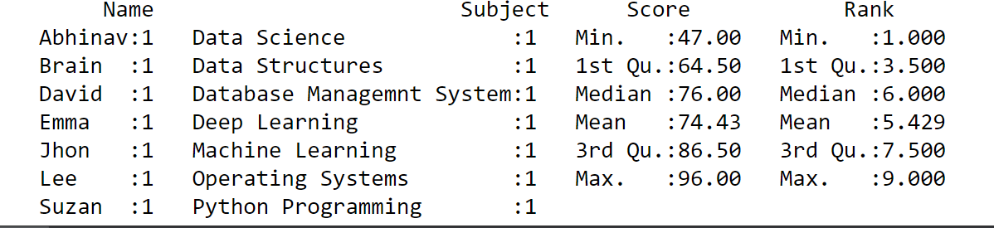**Output:**

**Explanation:**

Summary is a generic function used to produce result summaries of the results of various model fitting functions.

The function invokes particular methods which depend on the class of the first argument

The form of the value returned by summary depends on the class of its argument

**Date: 02/11/2020**

**Q.NO 5: Question**

Write a R program to extract specific column from a data frame using column name

**Program:**

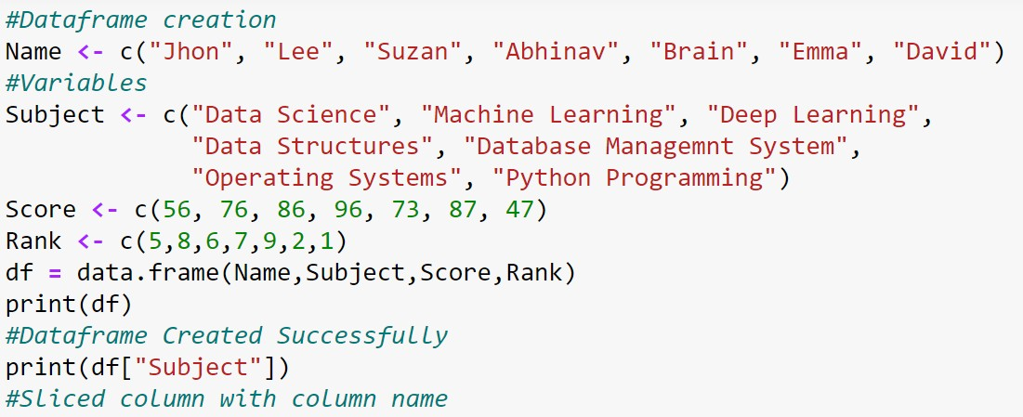

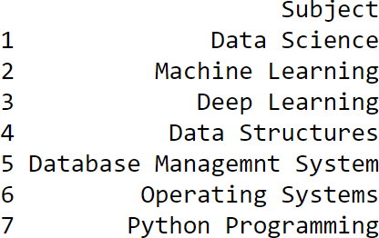**Output:**

**Explanation:**

* We retrieve a data frame column slice with the single square bracket "[]" operator.
* Here We can retrieve the same column slice by its name.
* And we can pack the row names in an index vector in order to retrieve multiple rows

**Date: 02/11/2020**

**Q.NO 6: Question**

.Write a R program to extract first two rows from a given data frame

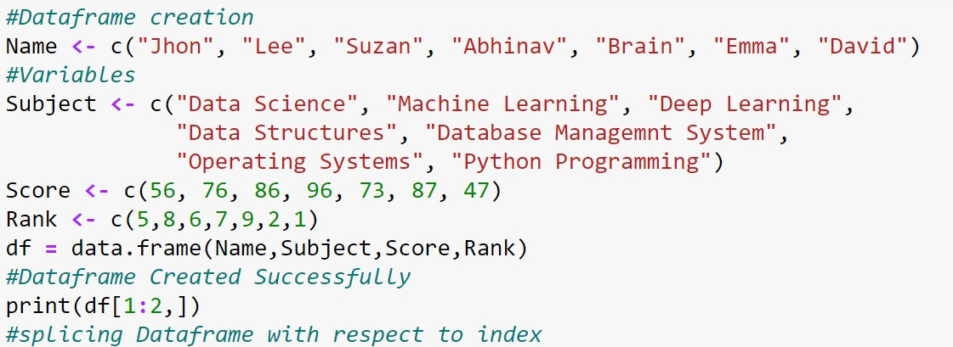**Program:**

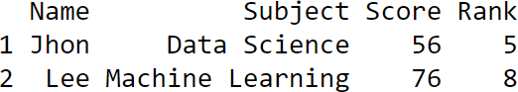**Output:**

**Explanation:**

* We retrieve rows from a data frame with the single square bracket operator, just like what we did with columns.
* However, in additional to an index vector of row positions, we append an extra comma character.
* This is important, as the extra comma signals a wildcard match for the second coordinate for column positions.

**Date: 03/11/2020**

**Q.NO 7: Question**

Create an R script that calculates the square root of a given integer vector x of length one, if the value contained in x is negative it should return NA.

**Program:**

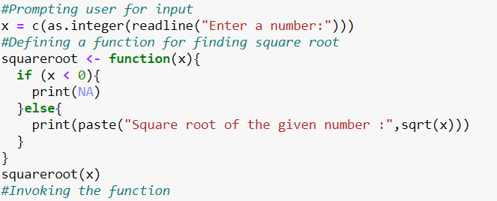

**Output:**

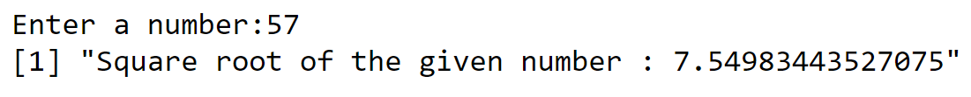

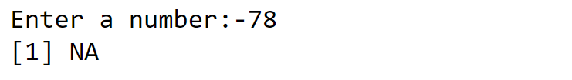

**Explanation:**

* Missing values are represented by the symbol **NA** (not available)
* If the numeric_Expression is a positive value, the sqrt function returns the square root of a given value.
* If the numeric_Expression is a negative value, the sqrt function return ***NaN***.
* Numeric_Expression is not a number (**NaN**), or Negative Infinity, then sqrt in R returns ***NaN***.

**Date: 03/11/2020**

**Q.NO 8: Question**

Demonstrate and examine the output of letter and LETTER

**Program:**

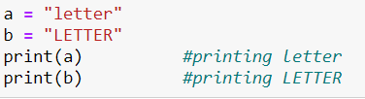

**Output:**



**Explanation:**

* This is useful because you can always view your data: just print it.
* You needn’t write special printing logic, even for complicated data structures.
* The print function has a significant limitation, it prints only one object at a time.
* Trying to print multiple items gives this mind-numbing error message

**Date: 03/11/2020**

**Q.NO 9: Question**

Create an R script that, given a numeric vector x with length 3, will print the elements by order from high to low.

**Program:**

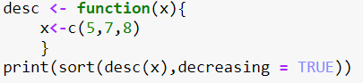

**Output:**



**Explanation:**

* Sort (or order) a vector or factor (partially) into ascending or descending order. For ordering along more than one variable, e.g., for sorting data frame
* To sort a data frame in R, use the **sort( )**function. By default, sorting is ASCENDING.
* Prepend the sorting variable by a minus sign to indicate DESCENDING order

**Date: 03/11/2020**

**Q.NO 10: Question**

Create an R script that returns the amount of values that are larger than the mean of a vector. You are allowed to use mean(). ( Use function)

**Program:**

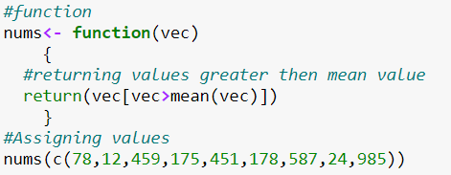

**Output:**



**Explanation:**

* It is calculated by taking the sum of the values and dividing with the number of values in a data series.
* The function **mean()** is used to calculate and decision operator “>” is used to compare the giving condition and take decision

**Date: 03/11/2020**

**Q.NO 11: Question**

Write a double for loop which prints 30 numbers (1:10, 2:11, 3:12). Those are three clusters of ten numbers each. The first loop determines the number of clusters (3) via its length; the second loop the numbers to be printed (1 to 10 at the beginning). Each cluster starts one number higher than the previous one

**Program:**

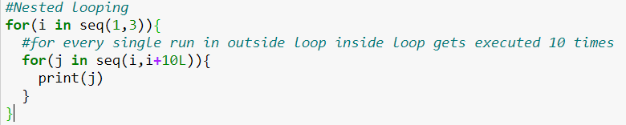

**Output:**



**Explanation:**

* In Nested for Loop, it makes use of the control structures to manage the execution of the expression, one such control structure is Nested for Loop a similar to basic ‘for’ loop executes.
* It can be defined as placing one ‘for’ loop inside the first ‘for’ loop is called as nesting or loop of loops in some terms, which takes the responsibility of two loops such that the outer loop controls the number of repetition of the whole inner detailed information until it is false,
* in other words, the inner loop executes n-times of every execution of the outer for loop and also, it’s a great tool to work with R Programming Language.

**Date: 03/11/2020**

**Q.NO 12: Question**

a. You have the data.frame ‘mydf’ with four columns like below

a = c(3,7,NA, 9) b = c(2,NA,9,3) f = c(5,2,5,6) d = c(NA,3,4,NA)

You want to add another column ‘5’: the 5th column contains the value of col 2 if col 1 is NA; the 5th column contains the value of col 4 if col 2 is NA; the 5th column contains the value of col 3 in all other cases.

**Program:**

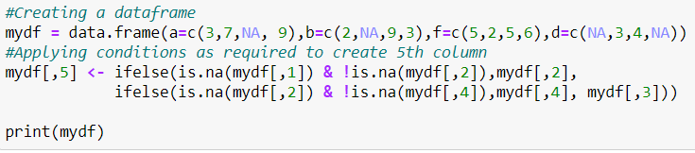

**Output:**

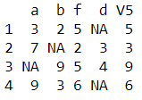

**Explanation:**

* An if statement can be followed by an optional else statement which executes when the Boolean expression is false.
* An if statement can be followed by an optional else if...else statement, which is very useful to test various conditions using single if...else if statement

**Date: 03/11/2020**

**Q.NO 13: Question**

Write a while loop starting with x = 0. The loop prints all numbers up to 35 but it skips number 7. Condition: If x== 7 next

**Program:**

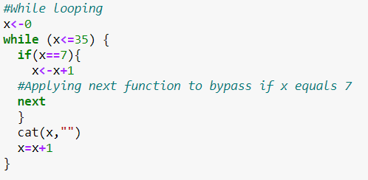

**Output:**



**Explanation:**

* The **next** statement in is useful when we want to skip the current iteration of a loop without terminating it.
* On encountering next, the R parser skips further evaluation and starts next iteration of the loop.in other words, the inner loop executes n-times of every execution of the outer for loop.

**Date: 03/11/2020**

**Q.NO 14: Question**

Examine the difference between typeof and class () method using R program

**Program:**

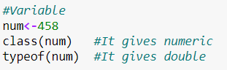

**Output:**

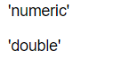

**Explanation:**

* 'class' is a property assigned to an object that determines how generic functions operate with it. It is not a mutually exclusive classification. If an object has no specific class assigned to it, such as a simple numeric vector, its class is usually the same as its mode, by convention.
* Typeof determines the (R internal) type or storage mode of any object

**Date: 03/11/2020**

**Q.NO 15: Question**

Create a function and demonstrate their features like required, keyword, default.

**Program:**

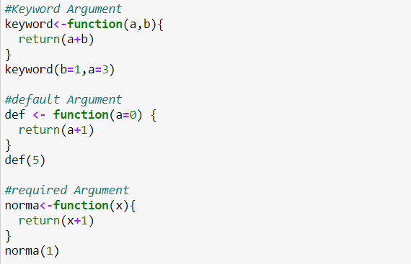

**Output:**

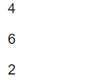

**Explanation:**

* Arguments are always named when you define a function. When you call a function, you do not have to specify the name of the argument.
* Arguments are optional; you do not have to specify a value for them. They can have a default value, which is used if you do not specify a value for that argument yourself.
* You can use as many arguments as you like, there is no limit to the number of arguments. An argument list comprises of comma-separated values that contain the various formal arguments.

**Date: 03/11/2020**

**Q.NO 16: Question**

Create a dataframe and delete the row and column. ( Use the own data values to create frame)

**Program:**

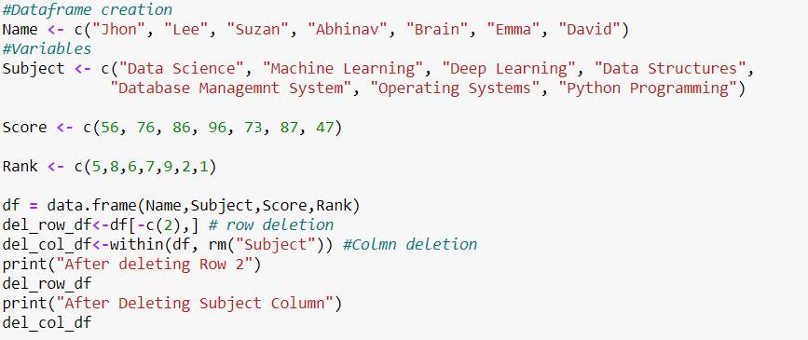

**Output:**

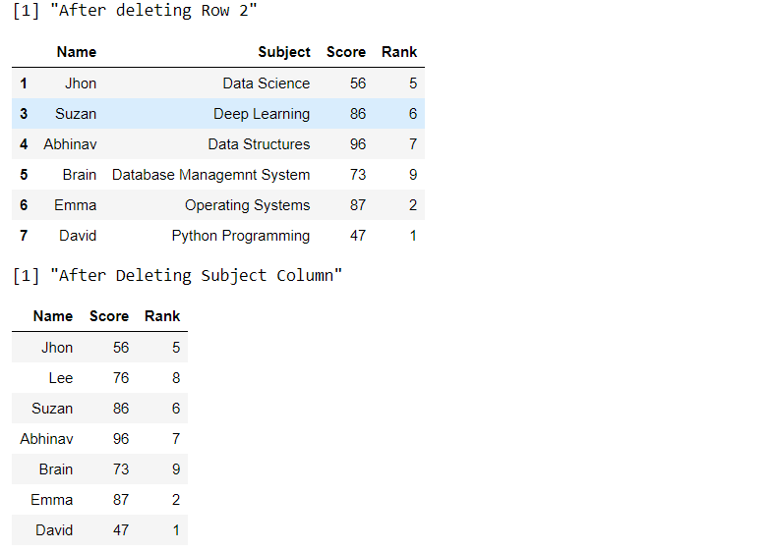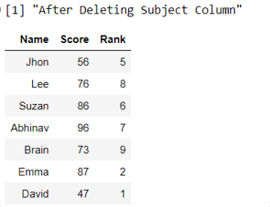

**Explanation:**

* -c(rowNum) is used to return a slice of a dataframe without the mentioned row i.e. row deletion
* The within function returns a subset of a dataframe with the second argument ad a function to apply to all the column rm function removes the “Subject” column out of the data frameTypeof determines the (R internal) type or storage mode of any object.